1)Create one Bash script to check if a directory is available or not.
steps:-
Ask the user to enter a directory name.
Use [ -d directory ] to check if it exists.
If it exists → print “Directory exists”.
If it doesn’t → print “Directory does not exist”.
Close the IF.

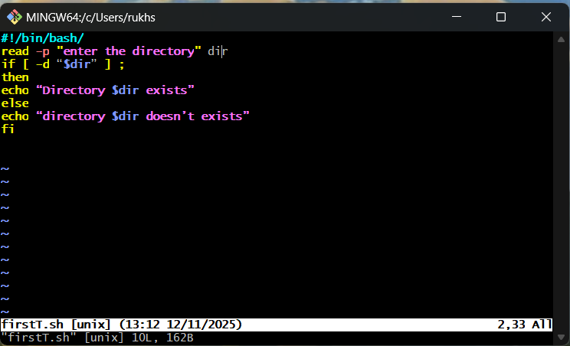
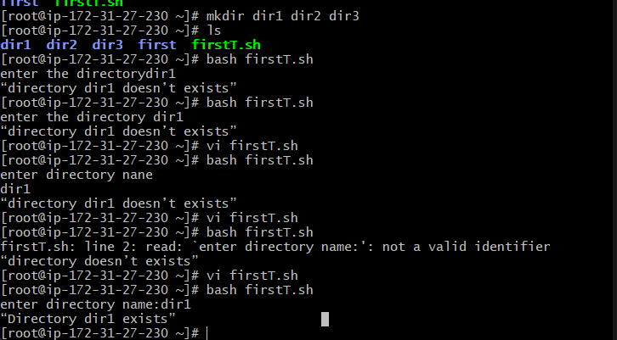
2) “Create a Bash script which will create multiple files.”
• Ask the user for a file prefix (example: file, test, log).
• Ask the user how many files they want to create.
• Use a for loop to repeat file creation.
• Inside the loop, use touch to create each file.
• Add numbers to each file name (file_1, file_2, file_3…).

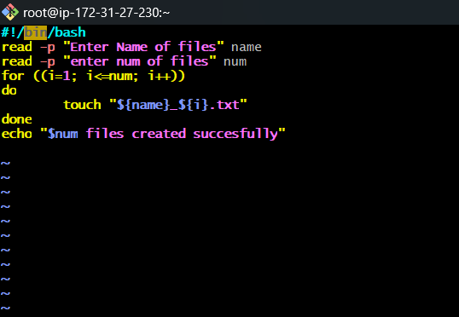
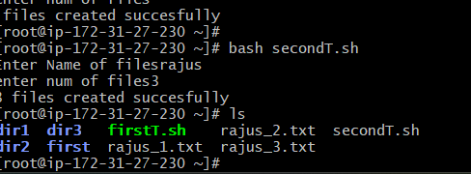
3)Create a bash script to take a backup of a directory.
• Ask the user for the directory name they want to back up.
• Use the tar command to compress the entire directory.
• Give the backup file a name (example: backup.tar.gz).
• Store the backup in the same location or a backup folder.
• Print a message saying backup is successful.

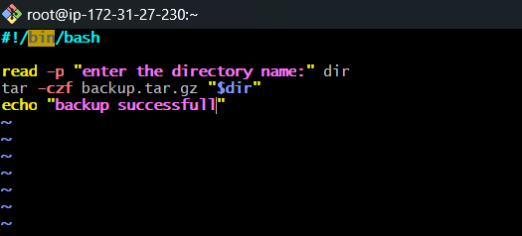
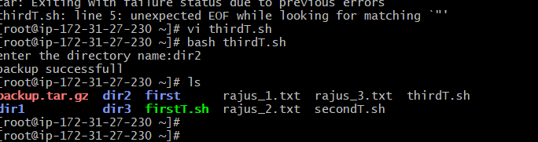
4) Create a bash script to install Nginx on an EC2 server.
• Update the system packages using the package manager.
• Install Nginx using yum (Amazon Linux) or apt (Ubuntu).
• Enable the Nginx service so it starts automatically on reboot.
• Start the Nginx service immediately.
• Print a message saying “Nginx installed and running”.

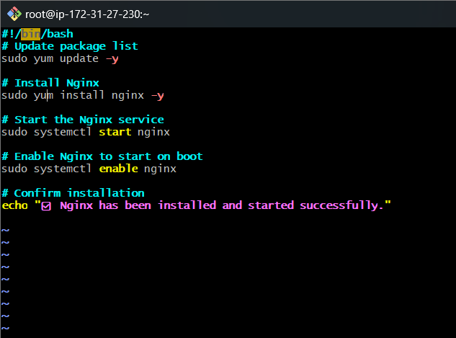
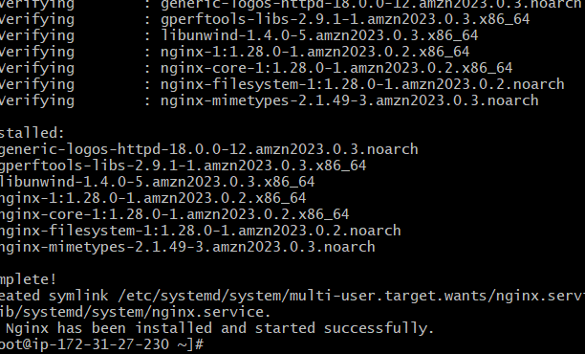
5)Create a bash script to install Apache Tomcat on an EC2 server.
• yum update → refreshes your EC2 server’s software list.
• Java installation → Tomcat is a Java-based server, so it cannot run without Java.
• wget → downloads the Tomcat zip file from the internet.
• tar → extracts the downloaded file and moves it into /opt/tomcat.
• startup.sh → the script that starts the Tomcat service.

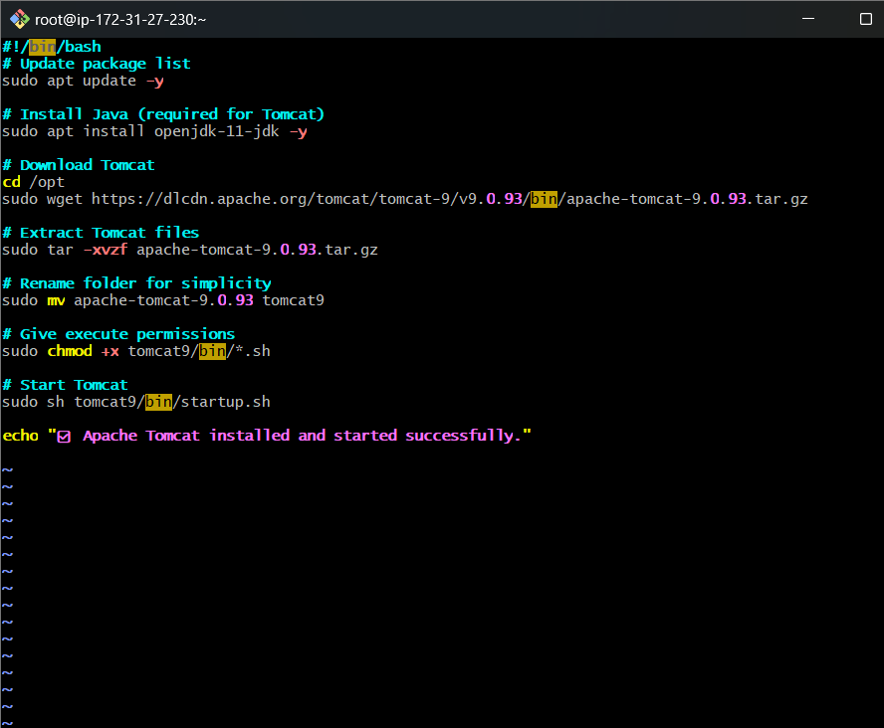
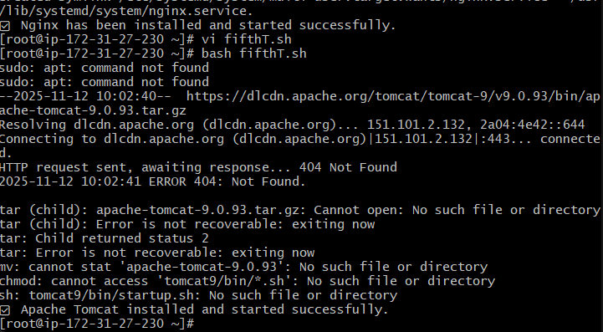6)Create a bash script to check if the Nginx service is running, if not running then script should start the service.
- systemctl is-active --quiet nginx checks if Nginx is currently running.
- if condition → If the service is running, script prints "Nginx is already running".
- If it is not running, the script goes to the else block.
- systemctl start nginx starts the Nginx service.
- The script helps auto-fix Nginx downtime by restarting it.

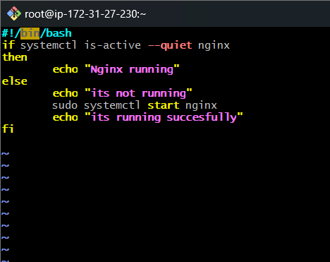
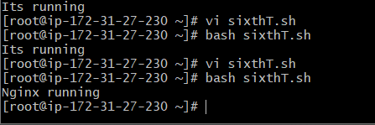
7)Create a bash script for a calculator.
• Script asks user for two numbers.
• Then asks which operation they want to perform (+, -, *, /).
• case statement checks which operator the user selected.
• Arithmetic is done using $(( )).

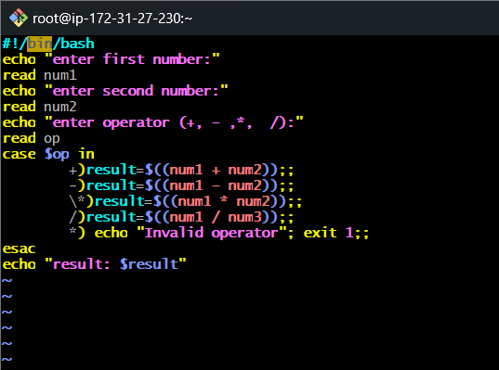
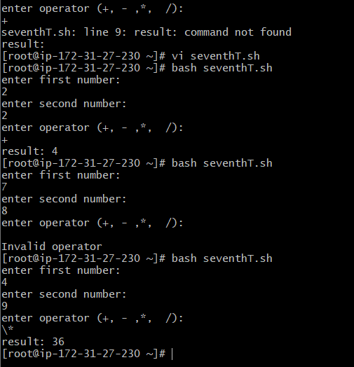
8)Create a bash script to check if a directory exists, if not then create a directory.
• First the script stores the directory name that we want to check.
• It uses if [ -d "directory" ] to check whether the directory already exists.
• If the directory exists, it prints a message saying it already exists.
• If the directory does not exist, the script runs mkdir to create it.
• At the end, it prints that the directory has been successfully created.

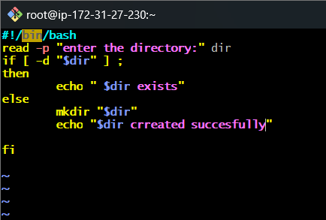
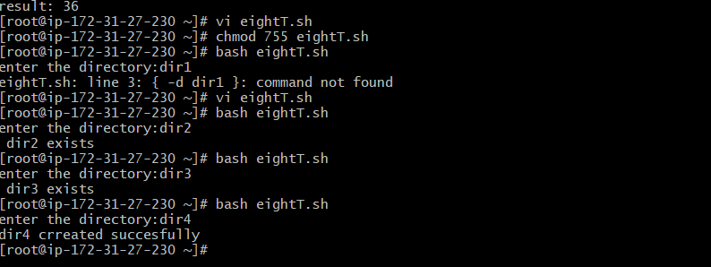

9)Create a bash script to delete the last 3 lines of a file.
- The script takes a filename as input.
- It uses the head command to print all lines except the last 3.
- The output of head -n -3 file is then redirected back to the same file.
- This effectively removes the last 3 lines from the file.
- The file gets updated with the remaining content only.

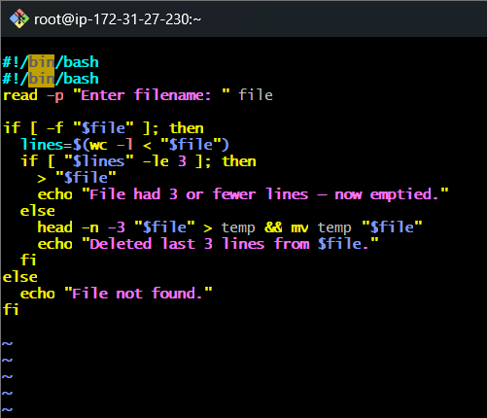:
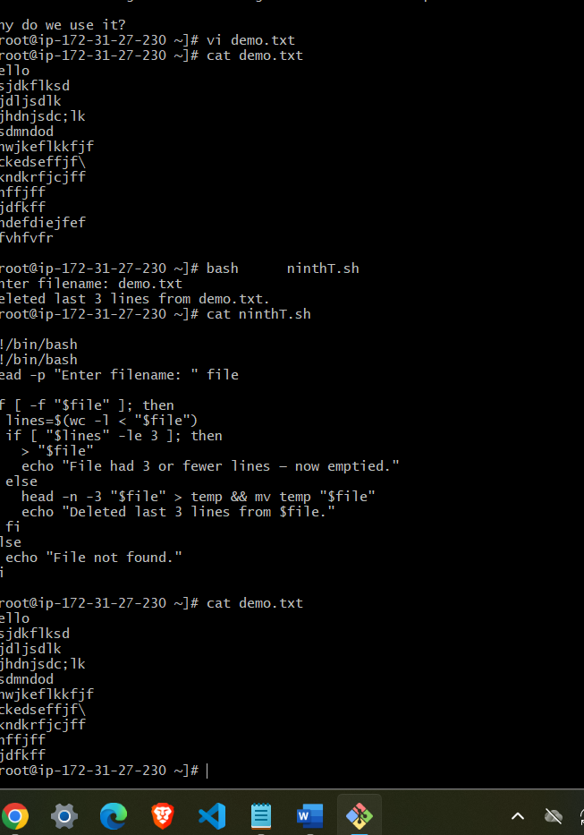

10)Bash script to monitor cpu and if it is more than 80% then send email notification.
• The script uses top or mpstat to check the current CPU usage.
• It extracts the CPU usage percentage and stores it in a variable.
• If the CPU value is greater than 80%, the script triggers an alert condition.
• It uses the mail command to send an email notification to the admin.
• This helps detect high CPU load and take action before server slowdown.

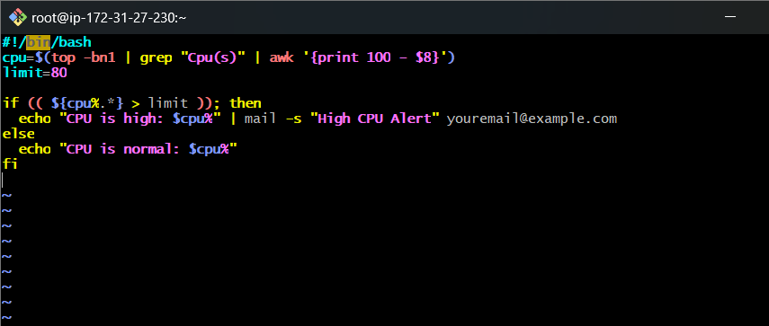
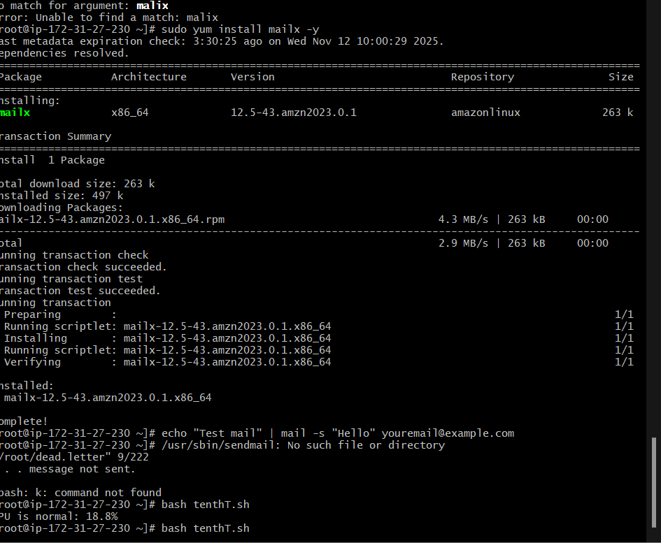

11)Bash script to monitor disk space and if it is more than 80% then send email notification.
• Script uses the df -h command to check disk usage of partitions.
• It extracts the percentage used for the root (/) or required filesystem.
• If the disk usage is more than 80%, the script enters the alert section.
• It sends an email using mail to notify about low space.
• This prevents server crashes due to full disk.

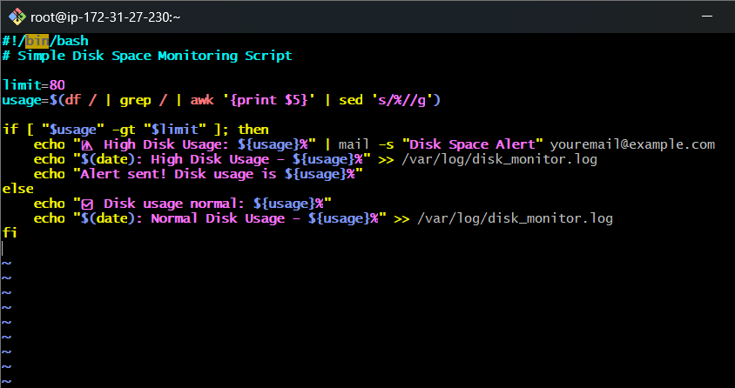
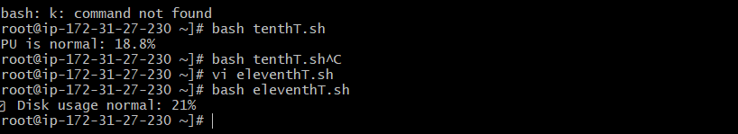
12)Bash script to monitor memory and if it is more than 80% then send email notification.
- he script uses the free -m command to check total and used memory.
- It calculates the percentage of memory used using a simple formula.
- If the memory usage is greater than 80%, the script enters the alert section.
- It uses the mail command to send an email notification to the admin about high memory usage.
- This helps prevent server slowdown or crashes caused by memory overload.

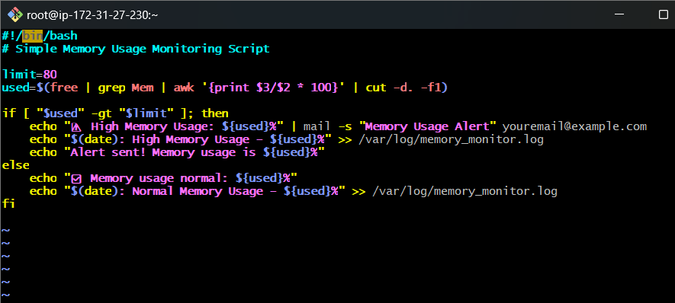
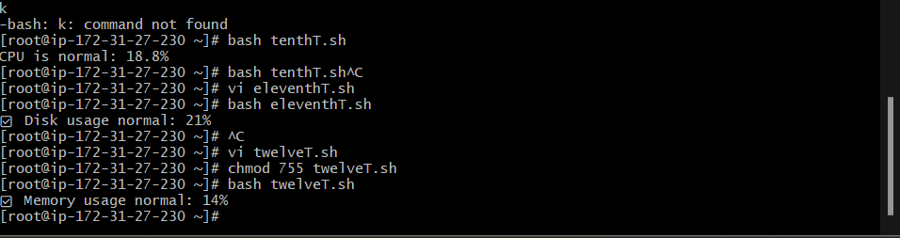

##crontab##
first install
sudo yum install cronie -y
crontab -e
crontab -l
